Colpitts Oscillator
Colpitts Oscillator is a type of LC oscillator which falls under the category of Harmonic Oscillator. Figure 1 shows a typical Colpitts oscillator with a tank circuit in which an inductor L is connected in parallel to the serial combination of capacitors C₁ and C₂ (shown by the red enclosure).
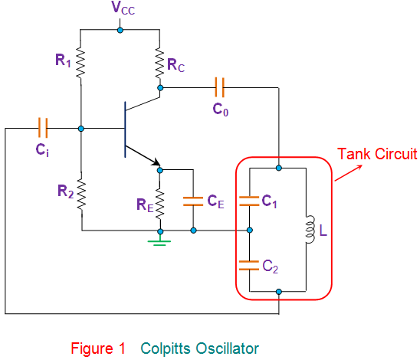
Other components in the circuit are the same as that found in the case of common-emitter CE which is biased using a voltage divider network i.e. R_{C} is the collector resistor, R_{E} is the emitter resistor which is used to stabilize the circuit and the resistors R₁ and R₂ form the voltage divider bias network. Further, the capacitors C_{i} and C_{o} are the input and output decoupling capacitors while the emitter capacitor C_{E} is the bypass capacitor used to bypass the amplified AC signals.
Here, as the power supply is switched ON, the transistor starts to conduct, increasing the collector current I_{C} due to which the capacitors C₁ and C₂ get charged. On acquiring the maximum charge feasible, they start to discharge via the inductor L. During this process, the electrostatic energy stored in the capacitor gets converted into magnetic flux which in turn is stored within the inductor in the form of electromagnetic energy. Next, the inductor starts to discharge which charges the capacitors once again. Likewise, the cycle continues which gives rise to the oscillations in the tank circuit.
Further the figure shows that the output of the amplifier appears across C₁ and thus is in-phase with the tank circuit’s voltage and makes-up for the energy lost by re-supplying it. On the other hand, the voltage feedback to the transistor is the one obtained across the capacitor C₂, which means the feedback signal is out-of-phase with the voltage at the transistor by 180º. This is due to the fact that the voltages developed across the capacitors C₁ and C₂ are opposite in polarity as the point where they join is grounded. Further, this signal is provided with an additional phase-shift of 180º by the transistor which results in a net phase-shift of 360º around the loop, satisfying the phase-shift criterion of Barkhausen principle.
At this state, the circuit can effectively act as an oscillator producing sustained oscillations by carefully monitoring the feedback ratio given by (C₁ / C₂). The frequency of such a Colpitts Oscillator depends on the components in its tank circuit and is given by
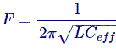
Where, the C_{eff} is the effective capacitance of the capacitors expressed as
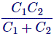
As a result, these oscillators can be tuned either by varying their inductance or the capacitance. However the variation of L does not yield a smooth variation. Hence they are usually tuned by varying the capacitances which are generally ganged, due to which a change in any one of them changes both of them. Nevertheless, the process is tedious and requires special large-valued capacitor. Thus, the Colpitts oscillators are seldom preferred in the applications where in the frequency varies but are more popular as fixed frequency oscillators due to their simple design. Further they offer better stability in comparison with the Hartley Oscillators as they are exempted from the mutual inductance effect present in-between the two inductors of the latter case.
Typically, the operating frequency of the Colpitts oscillators ranges from 20 KHz to 300 MHz however they can even be used for microwave applications as their capacitors provide low reactance path for the high-frequency signals. This results in better frequency stability as well as a better sinusoidal output waveform. Moreover, they are also extensively used as surface acoustical wave (SAW) resonators, sensors and in mobile and communication systems.

